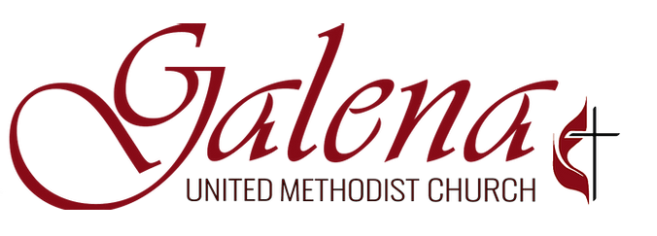

Leadership Board Member Job Description
Reports to: Chairperson of the Leadership Board
Primary Function: To provide strategic leadership and direction for Galenat United Methodist Church (GUMC) and align all ministries and functions with the mission and vision of the church.

Responsibilities/Duties:
The Life of Discipleship (Personally grow as a passionate disciple of Jesus Christ)
- Daily devotional time consisting of prayer and biblical engagement
- Faithful worship attendance
- Engaged in a Sunday School class or small group
- Consistently serve through the church in mission and ministry
- Contribute financially: consistently, proportionally, sacrificially
- Model a positive, light-of-Christ spirit

Mission Alignment and Fidelity
- Ensures that the mission of the GUMC to “love God, love neighbor, and make disciples” is the top priority of the church each year.
- Evaluates the success of the church’s ministries with alignment to the vision, mission and annual advances.
- Is willing to ask difficult questions, challenge current practices, and recommend changes so that the church can effectively fulfill its mission and vision.

Strategic Visioning and Goal Setting
- On an annual basis, reviews the current vision for the church and considers any needed modifications.
- Considers community needs and trends that impact ministries and vision of the church when making decisions.
- Finds ways for the church to experiment, innovate, take risks and adapt to meet the challenges of our ever-changing ministry landscape.
- Establishes strategic annual advances (goals) to achieve the stated vision and mission of the church.
- Ensure that we dream and plan greater than our resources (leaving room for God to work).

Accountability
- Exhibits personal accountability in the life of discipleship, supporting decisions of the Leadership Board (debate inside, alignment outside), and be a cheerleader within the congregation.
- Holds fellow Leadership Board members accountable to shared leadership responsibilities and the life of discipleship.
- Holds the Senior Pastor accountable to effectively lead the staff and ministries of the church for alignment to the mission and vision of the church and achievement of the annual strategic advances.
- Working with the Senior Pastor, identifies the most effective way to structure staffing to achieve the mission and vision of the church.
- Holds working committees accountable to alignment with the church’s mission and progress towards achieving stated goals.
- Routinely seeks input from the congregation and ministry leaders to ensure the church is dealing appropriately with leadership issues.

Administration
- Sets operating guidelines and policies for the church.
- Evaluates church’s current administrative operations and policies and makes changes as needed.
- Sets annual budget for the church and establishes financial spending limits for staff and ministry teams. Reviews any requests above those limits and evaluates any significant, unexpected expenditures needs during the year.
- Handles staff/parish relations issues as needed and maintains appropriate confidentiality.
- In order to maintain transparency with the congregation, oversees annual communication of the church’s progress and any challenges that arise in meeting annual goals. Working with the pastor, determines when additional communication needs to occur with the congregation on critical issues throughout the year.
- Follows all operating guidelines established for the Leadership Board.

Time Commitments
- Meetings – Faithful attendance at monthly board meetings and special called meetings is critical. Failure to attend meetings could result in removal from the board.
- Possibility of called meetings several times a year on critical issues if necessary.
- Preparation prior to each monthly meeting to review documents that will be discussed at the monthly meeting.
- Annual retreat of the Leadership Board.
- Participation in town hall meetings with the congregation to share church’s progress and any challenges.
- Commitment to a three-year term.
Competencies Needed for Serving on the Leadership Board
Each Board member should possess a few of the following competencies:
Spiritual Gifts:
- Leadership
- Administration
- Discernment
- Wisdom
Interests or Passions:
- Desire to seek the Lord’s will and direction for this body of believers at this time in this place
- Desire to guide the church in identifying the most relevant vision for the church based on community and congregational needs.
- Desire to see the advancement of the Kingdom of God on earth as it is in heaven.
- Commitment to ensure that the church’s operations and ministries are aligned with the mission and vision of the church.
- Desire to help the church experiment, innovate, take risks and adapt to meet the challenges of our ever-changing ministry landscape.
- Desire to provide leadership to ensure the church functions at a high level of operational effectiveness and in accordance with United Methodist guidelines.
Abilities and Skills:
- Ability to provide leadership and direction to the overall vision and mission of the church
- Ability to think strategically
- Ability to be decisive when needed, yet able to understand when more information is needed before critical decisions are made
- Skills in dealing with conflict in appropriate ways
- Ability to work collaboratively within a team (not a lone ranger)

